Name: Hour

Marketing mix refers to the set of actions, or tactics, that a company uses to promote its brand or product in the market. How to get your idea to the marketplace.
- Also known as the 4Ps of marketing because all marketing functions and decisions are put in the nice tool known at Price, Product, Promotion and Place.
- Lets look at the happy meal: 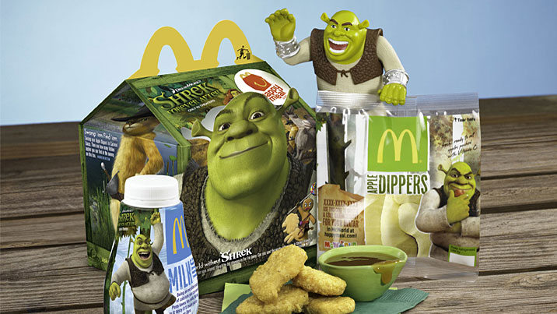
- In Groups at your table, fill in the boxes for each:
McDonald’s Happy Meal
Product: | Place: Where is it being Sold (3 answers)
Brand

Packaging (specific details) 3-4 ideas

What is included:

Price | Promotion: Where advertising it

Now you create your own Happy meal. You cannot use Chicken Nuggets as the meal type. Blue sky, what would you offer in a Happy meal?
Go to google and learn of the new top movies for kids. Create some ideas of your happy meal using the 4ps or marketing. Create two meal options to choose from with different pricing based on meal type.
McDonald’s Happy Meal
Product: | Place: Where is it being Sold (3 answers)
1st Option:

Brand
Packaging (specific details) 3-4 ideas

What is included in option 1:

2nd Option:

Brand
Packaging (specific details) 3-4 ideas

What is included in option 2:

Price | Promotion: Where advertising it

